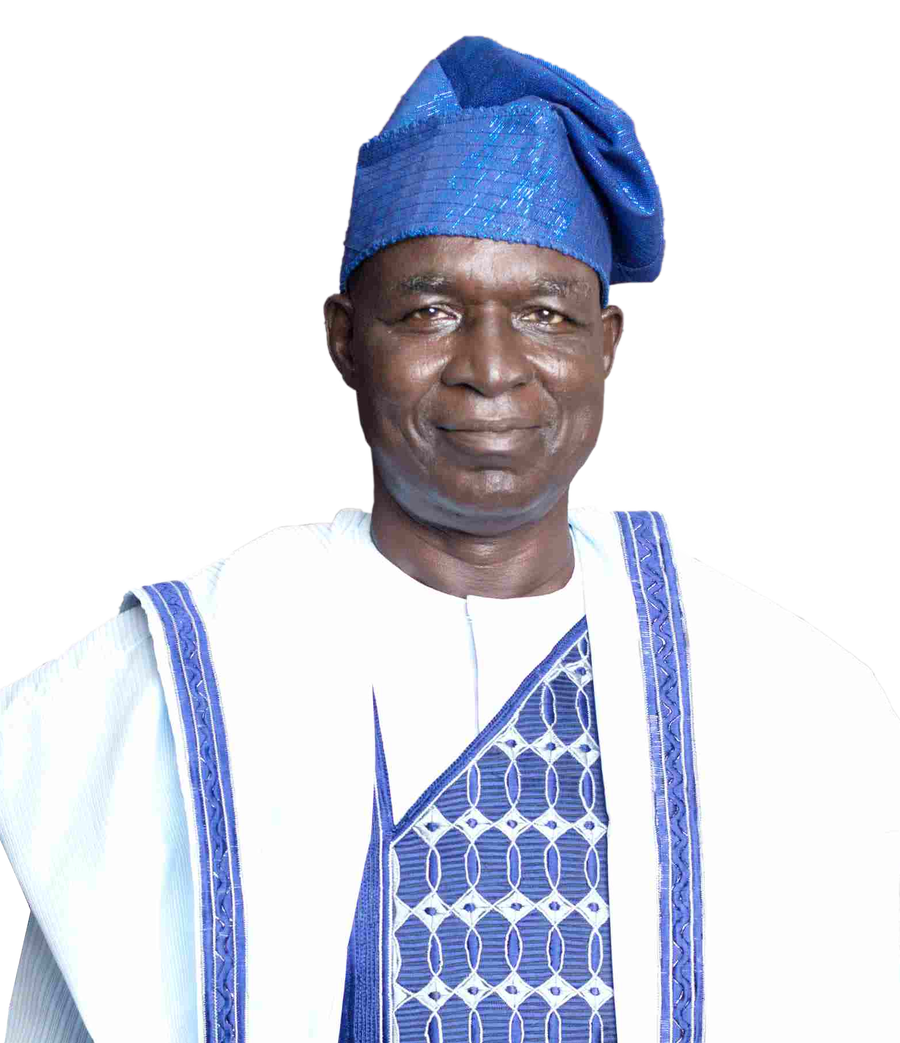

**(27th September 1949 – 5th March 2024)**

**Glorious Exit Late Hon. Baba Eli Gamaliel Tahbi**

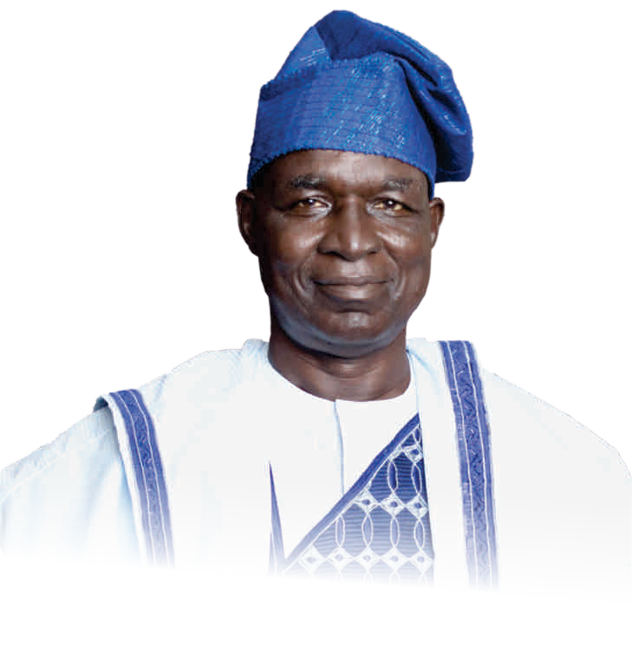

**S***S***O***er***N***vic***G***e O***S***f*

IN HONOUR OF

### Late Hon. Baba Eli Gamaliel Tahbi

**(27th September 1949 – 5th March 2024)**

DATE: 26TH MARCH, 2024

@ Nuhu Musa Hall Asokoro Community School, FCT Abuja.

Time: 3:00pm

## Offciating Ministers

1. Rt. Rev. Benjamin Jonathan Fuduta (Bishop Lutheran Church of Christ in Abuja Diocese )
2. Pastor Akinola Olabisi (RCCG Peace House Assembly)
3. Pastor Michael Olarundare (Family Worship Centre Asokoro)
4. Rev. Pius Ilya (Lutheran Church of Christ in Nigeria Nyanya)

**-01-**

**Glorious Exit Late Hon. Baba Eli Gamaliel Tahbi**



**Commendation**

**& Service of Songs**

*Order of* s*ervice*

1. Call to Worship
2. Hymn: "How Great Thou Art" 3.Thanksgiving Prayer

4.Hymn: "There's a Land that is Fairer than Day" 5.First Scriptural Reading: 1 Thessalonians 4:13-18 6.Hymn: "There's Not a Friend Like the Lowly Jesus" 7.Second Scriptural Reading: Revelation 21:1-7

8.Special Song ministration by Zumunta Mata LCCN Nyanya 9.Goodwill Message from Lunguda Community in Abuja 10.Goodwill Message from Adamawa State Community in Abuja 11.Hymn: "My Hope Is Built on Nothing Less"

12.Responsive Reading: Psalm 136:1-26 13.Hymn: "It Is Well"

14.Third Scriptural Reading: Matthew 25:11-13 15.Hymn

16.Testimonies by Friends, Colleagues, and Church Members 17.Special Number

1. Sermon
2. Special Prayer for the Family 20.Hymn: "Because He Lives"
3. Recognition/Announcements and Vote of Thanks 22.Prayer of Benediction

**Glorious Exit Late Hon. Baba Eli Gamaliel Tahbi**

*Fu***S***ne***E***ra***R***l*

**VICE**

IN HONOUR OF

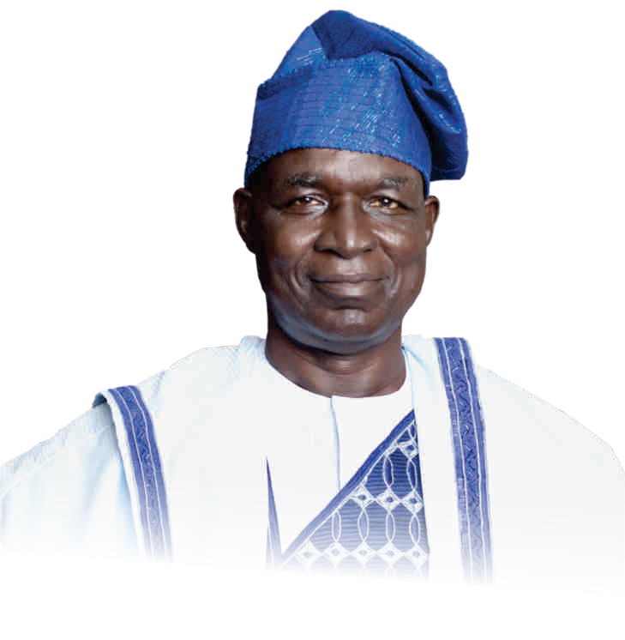

**Late Hon. Baba Eli Gamaliel Tahbi**

DATE: 28TH MARCH, 2024

AT LCC CHURCH GUYUK, ADAMAWA STATE.

Time: 10:00am

## Offciating Ministers

* 1. Bishop Peter Bartholomew ( Gumni Maikudi Guyuk ) 2.Bishop Gumni Mikudi

1. Rev. Godwin Grema (Lutheran Church of Christ in Nigeria CATHEDRAL Guyuk)
2. Pastor Celestine Onyeator ( Kings Court Guyuk RCCG)

**-01-**

**Glorious Exit Late Hon. Baba Eli Gamaliel Tahbi**



*Order of* s*ervice*

1. Call to Worship
2. Hymn- How Great Thou Art 3.Thanksgiving Prayer

4.Hymn- There's a Land that is fairer than Day 5.Scriptural Reading 1- Luke 16:19-31

6.Hymn- There's Not a friend like the lowly Jesus 7.Scripture Reading 2. Romans 8:35-39

1. Special song by Zumunta Mata
2. Good will message from Lunguda Community in Abuja 10.Goodwill message from Adamawa State Community in Abuja 11.Hymn- My hope is built on Nothing Less

12.Responsive Reading. Psalm 136: 1-26 13.Hymn- It is well

14.Scripture Reading 3 - Mathew 25: 11-13 15.Special prayer for the family.

1. Hymn-
2. Testimonies by Friends, colleague and Church 18.Special number

19.Message 20.Internment

21.Recognition and Vote of thanks

#### -01-

**Glorious Exit Late Hon. Baba Eli Gamaliel Tahbi**

**HYMNS**

1. **HOW GREAT THOU ART 3. GREAT IS THY FAITHFULNESS**

Verse 1



O Lord my God, when I in awesome wonder Consider all the works Thy hands have made, I see the stars, I hear the rolling thunder,

Thy pow’r thru-out the universe displayed!

Chorus

Then sings my soul, my Savior God, to Thee; How great Thou art, how great Thou art!

Then sings my soul, my Savior God, to Thee; How great Thou art, how great Thou art!

Verse 2

When thru the woods and forest glades I wander And hear the birds sing sweetly in the trees, When I look down from lofty mountain grandeur And hear the brook and feel the gentle breeze,

Verse 3

And when I think that God, His Son not sparing, Sent Him to die, I scarce can take it in –

That on the cross, my burden gladly bearing, He bled and died to take away my sin!

Verse 4

When Christ shall come with shout of acclamation And take me home, what joy shall fill my heart!

Then I shall bow in humble adoration

And there proclaim, my God, how great Thou art!

1. **THERE’S A LAND THAT IS FAIRER THAN DAY**

***Verse 1***

There's a land that is fairer than day, And by faith we can see it afar,

For the Father waits over the way

##### To prepare us a dwelling place there.

***Chorus***

##### In the sweet by and by,

We shall meet on that beautiful shore; In the sweet by and by,

##### We shall meet on that beautiful shore.

***Verse 2***

##### We shall sing on that beautiful shore The melodious songs of the blest; And our spirits shall sorrow no more- Not a sigh for the blessing of rest.

***Verse 3***

##### To our bountiful Father above We will offer our tribute of praise For the glorious gift of His love

And the blessings that hallow our days.

#### -01-

Verse 1

Great is Thy faithfulness, O God my Father; There is no shadow of turning with Thee;

Thou changest not, Thy compassions, they fail not; As Thou hast been, Thou forever will be.

Chorus

Great is Thy faithfulness! Great is Thy faithfulness!

Morning by morning new mercies I see. All I have needed thy hand hath provided; Great is Thy faithfulness, Lord, unto me!

Verse 2

Summer and winter and springtime and harvest, Sun, moon and stars in their courses above

Join with all nature in manifold witness To Thy great faithfulness, mercy and love.

Verse 3

Pardon for sin and a peace that endureth

Thine own dear presence to cheer and to guide; Strength for today and bright hope for tomorrow, Blessings all mine, with ten thousand beside!

**4. THERE'S NOT A FRIEND LIKE THE LOWLY JESUS**

1. There’s not a Friend like the lowly Jesus: No, not one! no, not one!

None else could heal all our souls’ diseases: No, not one! no, not one!

***Chorus***

Jesus knows all about our struggles; He will guide ’til the day is done:

There’s not a Friend like the lowly Jesus: No, not one! no, not one!

1. No friend like Him is so high and holy, No, not one! no, not one!

And yet no friend is so meek and lowly, No, not one! no, not one!

1. There’s not an hour that He is not near us, No, not one! no, not one!

No night so dark, but His love can cheer us, No, not one! no, not one!

**Glorious Exit Late Hon. Baba Eli Gamaliel Tahbi**

1. Did ever saint find this Friend forsake him? No, not one! no, not one!

Or sinner find that He would not take him? No, not one! no, not one!

1. Was e’er a gift like the Savior given? No, not one! no, not one!

Will He refuse us the bliss of heaven? No, not one! no, not one!

#### IT IS WELL

Verse 1

When peace, like a river, Attendeth my way,

When sorrows like sea billows roll; Whatever my lot,

Thou has taught me to say, It is well, with my soul.

It is well, it is well, with my soul.

Verse 2

Though Satan should buffet, Though trials should come, Let this blest assurance control, That Christ has regarded

My helpless estate,

And hath shed His own blood for my soul. It is well, with my soul,

It is well, it is well, with my soul.

Verse 3

My sin, oh, the bliss

Of this glorious thought!

My sin, not in part but the whole, Is nailed to the cross,

And I bear it no more,

Praise the Lord, praise the Lord, O my soul! It is well, with my soul,

It is well, it is well, with my soul.

Verse 4

And Lord, haste the day When my faith shall be sight,

The clouds be rolled back as a scroll; The trump shall resound,

And the Lord shall descend, Even so, it is well with my soul. It is well, with my soul,

It is well, it is well, with my soul. No, not one! no, not one!

1. **MY HOPE IS BUILT ON NOTHING LESS**

Verse 1

My hope is built on nothing less Than Jesus’ blood and righteousness. I dare not trust the sweetest frame, But wholly lean on Jesus’ Name.

On Christ the solid Rock I stand, All other ground is sinking sand; All other ground is sinking sand.

Verse 2

When darkness veils His lovely face, I rest on His unchanging grace.

In every high and stormy gale, My anchor holds within the veil. On Christ the solid Rock I stand, All other ground is sinking sand; All other ground is sinking sand.

Verse 3

His oath, His covenant, His blood, Support me in the whelming flood. When all around my soul gives way, He then is all my hope and stay.

On Christ the solid Rock I stand, All other ground is sinking sand; All other ground is sinking sand.

Verse 4

When He shall come with trumpet sound, Oh may I then in Him be found.

Dressed in His righteousness alone, Faultless to stand before the throne. On Christ the solid Rock I stand, All other ground is sinking sand; All other ground is sinking sand.

1. **BECAUSE HE LIVES**

Verse 1

God sent His Son they called Him Jesus He came to love heal and forgive He bled and died to buy my pardon An empty grave is there to prove My Savior lives

Chorus 1

Because He lives I can face tomorrow Because He lives all fear is gone Because I know He holds the future And life is worth the living Just because He lives

Verse 2

How sweet to hold our newborn baby And feel the pride and joy he gives But greater still the calm assurance This child can face uncertain days Because Christ lives

Verse 3

And then one day I'll cross that river I'll fight life's final war with pain And then as death gives way to vict'ry I'll see the lights of glory

And I'll know He reigns

#### -01-



***INTRODUCTION:***

**Glorious Exit Late Hon. Baba Eli Gamaliel Tahbi**

BIOGRAPHY

***of***

Late Hon.

Baba Eli Gamaliel Tahbi

are his late father (Baba Gamaliel Tahbi) and his beautiful wife (Adah Eli), his late Father was his mentor and role model. Some friends and family

King Solomon presents four picture of life and attaches to each a practical admonition;

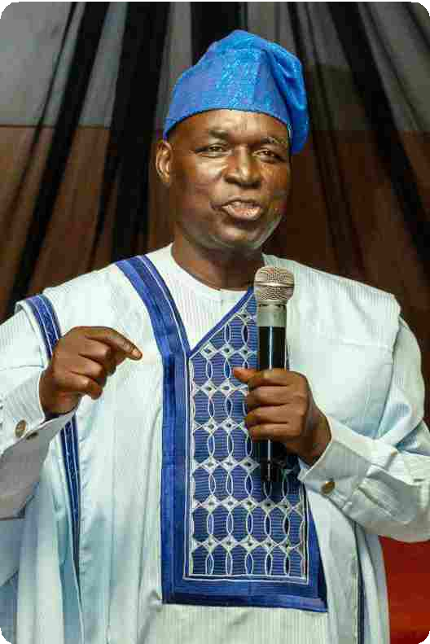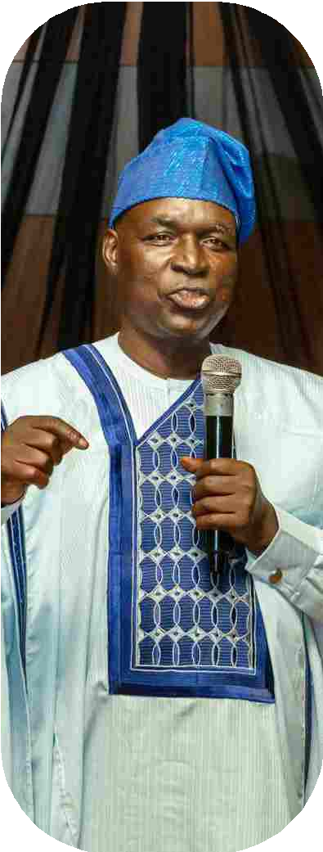

1. LIFE is an adventure “live by faith” Eccl 11:1-5
2. LIFE is a gift “enjoy it” Eccl 11:1-6
3. LIFE is a school “learn your lessons” Eccl 11:7-9
4. LIFE is a stewardship “serve” Eccl 12:9-12

Life is an adventure of Faith and not monotonous. Death is certain, but life is a gift from God and He wants us to live and enjoy it to the fullest.

This is a little insight of Baba Hon, Eli Gamaliel life's story from birth till date. However, there are two people who have influenced his life greatly and they

#### -01-

members at, one point or the other also played great roles in who he became.

PLACE OF BIRTH AND FAMILY LIFE

He is Lunguda by tribe, Lunguda is a small tribe in Adamawa State and in some part of Gombe State. The Lunguda people mainly live in Guyuk L.G.A in the southern part of Adamawa State.

His ancestry can be traced to a village called Gubara,

but later his father moved to Gwana where he started his family. Baba Eli Gamaliel was born on the date the Second World War ended on 27/09/1949 into the

**Glorious Exit Late Hon. Baba Eli Gamaliel Tahbi**

family of Baba Gamaliel Tahbi (This date was confirmed by one of the soldiers that returned from the war). He was the second child of the family and some of his siblings are; Vilson, Susume, Peter, Ayigeyiga, Buriba, Enwi, Sabo, Wunga, Araga, Dwanga, and Gandume.



HIS FATHER, THE MENTOR

His father was a farmer and a trader, and by local standard he was a very successful businessman. As his business expanded, he moved from Gwana to Guyuk which was the headquarters of the district, in search of a bigger market.

The UTC shops in Guyuk where his father traded was

close to the River Gongola, where his father distributed and retailed essential commodities such as sugar, soap, tea and clothing items. He had a big shop in Guyuk Market where people from surrounding villages came to buy their household items, indeed It was a local supermarket.

His father's success as a trader and farmer was evident

by the fact that he was among the first few people in Guyuk to build a house with a Zink roof, and in those days, that was a very big deal. He also acquired oxen for plowing, and bought a motor-van for transportation respectively.

During the second republic, his father went into

politics and sponsored individuals into political offices. As a result, the Government awarded him with the contract of feeding students at the Government day secondary school Guyuk.

His father was a philanthropist, and that had a huge

impact on him (Baba Eli). For instance, there was a period of famine in the entire Numan Federation in the 1970's due to drought. People were dying of hunger and some relocated out of the region, particularly in Guyuk, Baba Gamaliel in his usual manner as a philanthropist, would travel to Jalingo town which is present day Taraba State capital and buy garri, which he sold to families at a very subsidize rate, in other words he made no profit on it. As a result

#### -01-

of that, his house was always crowded with people trying to purchase the garri. For those who did not have money he gave them on credit.

HIS EARLY LIFE

At 3 years old when his father moved from Gwana to Guyuk, his elder brother was taken to their maternal uncle “Baba Bilala”, to tend his animals as was the Lunguda tradition and culture (Matrilineal in nature).

So, he automatically became the first child in the house and took up the responsibilities of the first born of the house. At the age of 5, he started going to the market with his father. He was trained in informal book keeping and marketing. His father opened his shop by 8am or 10 am, after which his father will leave the responsibility of managing the shop to him and travel either to Shelleng to buy some goods or go to the farm. When he returns later in the day, he (Eli) was relieved to go and play with his friends in the neighbourhood. Most of the time those games ended with a fight, but before the end of the day, all quarrels will be settled by elders and all the children ended up eating together.

This was the circle of his life growing up in the village. However, his father loved him so much that he did not allow anybody take him (Baba Eli) away from him as it was the custom/tradition then. His mother's brothers tried to take him, but they couldn't because his father was determined to send him to school to receive formal education and therefore refused to let him stay with his uncles.

GOING TO SCHOOL

He was hurriedly rushed to start school before he was matured enough just to avoid being taken by his uncles who wanted him to be a Shepard boy. So instead of direct entry to primary one, he started from pre-primary, because at that time your hands had to go over your head to touch your opposite ear before you could be admitted into primary 1.

His exposure to figures at his father's shop gave him

**Glorious Exit Late Hon. Baba Eli Gamaliel Tahbi**

an advantage over his mates, so he was soon promoted to primary one after only 3 months in the pre-primary section.



He entered junior primary school in 1956 and as soon as senior primary school was opened in Guyuk, he was among the 1st set, and graduated in 1964. To be a graduate of senior primary school in those days was almost as equal as obtaining a Senior Secondary School Certificate.

Going to Secondary School was very tough, there were very few colleges and secondary schools, therefore limited vacancies, and you have to be able to pass a common entrance examination and interview to get into any of the colleges.

In 1964 he (Baba Eli) sat for the common entrance exams. In a class of forty-four (44) pupils, only two of them were lucky to pass and gained admission into secondary and teachers college.

Furthermore, he always said that his secondary school days were the most interesting part of his school life, because that was the first time he moved out of the village to the city and also met pupils from other backgrounds. His school was a new school, called “Bronnum Secondary School” and he was among the second set of students to graduate in the school.

When he was in form 4, he was made the Head-boy of the school, (this position was only given to students with great academic performance and good morals). This position was challenging, but regardless, during his graduation he received the award for the best in Health Science.

In 1969 when he graduated from the secondary school, he proceeded to Zaria school of basic studies. ***NURSING TRAINING***

After his school of basic studies, which is usually one year, he proceeded to Jos Plateau State, which was then Benue-Plateau for nursing school and graduated after four years of training in the school of nursing, and was then posted to the General Hospital Yola in 1974.

HIS CARRER IN POLITICS AND LABOUR

As a child, he observed his father organizing meetings of politicians in their house, of which he was eventually recruited as their secretary for those political meetings because he was the only one around who could read and write. His duties included writing invitation letters, marking the register of attendance and recording financial transactions, all these influenced and shaped his capacity to coordinate and organise well informed political activities Locally and Nationally.

In his quest for knowledge, he later proceeded to

A.B.U Zaria to study psychology and human anatomy, while in the university, he joined student politics; and also had contact with radical lecturers, like Bala Usman, Patrick Wulimet, Bala Takaya who organize lectures for radical change. In fact, this had a great influence on him and his political career.

Before he graduated from the university, he joined UPN and became the chairman student wing, while His Excellency Boni Haruna. The former Governor of Adamawa State between 1999-2007 was his secretary.

After graduating from A.B.U Zaria he returned to Yola Adamawa State as a lecturer in the school of nursing. However, as a lecturer he was deeply involved in organise Labour struggles, where he met and worked with Mr. Paschal Bafyua, the Former National Leader of the Nigerian Labour Congress (NLC). Because of his commitment to labour struggle, late Comrade Pascal Bafyua asked he “Baba Eli” to organise the NLC structure in Adamawa State being a new state created from the defunct Gongola State in the year 1991.

While in NLC, they continue to mobilize and push for change to civil rule, and lecturers in higher institutions were their contact and resource persons. However, in 1989, when Gen. Ibrahim Badamasi Babagida planned a review of the constitution and members were elected on non-party basis, which Lead to Hon. Baba Eli to be elected to represent

#### -01-

**Glorious Exit Late Hon. Baba Eli Gamaliel Tahbi**

Guyuk/Shelleng Federal Constituency at the assembly, after which political associations were formed and he joined the Social Democratic Party (SDP) and became its P.R.O in Adamawa State under the chairmanship of Barr. Dr. Boss Gida Mustapha, the former Secretary to the Government of the Federation.



He was national coordinator for Prince Baba Adi presidential campaign and later coordinator for the Middle belt region to “Chief Arthur Nzerebe” presidential campaign team.

After the June 12 and the military takeover, all political activities came to a halt in the country, hence his transition into the hospitality industry, where he worked in Abuja Sheraton Hotels and Towers, and resigned as the Director Human Resources in the year 2007 and later returned to active politics in both State and National level. Above all, late Baba Hon. Eli Gamaliel was a seasoned and composite grassroots politician of all time.

MARRIAGE AND FAMILY

He first met his wife Adah Shadaya in June 1974 in Maiduguri during documentation for Nursing school graduates., and immediately knew in his spirit and body that he had found his soul mate. She was a young, brown skinned and extremely beautiful lady who was neatly dressed. She was sitting by herself and he had to gather all the strength within him to approach her and started up a friendly conversation.

Their discussion was not encouraging as he (Eli) was a bit shy and she was a bit passive. But as soon as the posting came out, they were both posted to Yola General Hospital. Thereafter, their relationship deepened in Yola, and she began to warm up to him. Everyone around them, especially at the work place knew that they were in a relationship.

After a period of dating and getting to know each other, he proposed to her and she accepted. He then quickly informed his father, who reached out to her parents, and asked for the bride price, which was paid

in the sum of N60. They later got married.

In 1975 their 1st son Suri was conceived and born through a caesarean section, it was a delicate and complicated procedure. The doctor in the process committed some errors that led to two subsequent operations, after which it was medically concluded that his wife cannot be pregnant again, but miraculously God visited them and his wife conceived, but afterward they lost the baby on health grounds and so they gave up hope of having other children.

God in His mercies still showed up for them, and blessed them with more children. They are proud parents to 3 young men.

HIS TESTIMONY

His life has been nothing short of a testimony; God has been extremely good to him. his darling wife and him have lived their lives void of any health issues, For the most part of his life he had shuffled between Yola and Abuja, and most of the time he drives himself to and fro, and God in His infinite mercies has sustained him. Through all his business and political pursuits God has kept him.

By the special grace of God Almighty, his children are all alive and thriving in all their endeavours and pursuit. Two of which are happily married and he is blessed with beautiful 7 (seven) grandchildren.

What will be your testimony, when you are gone? Live with eternity in view!!

#### -01-

**Glorious Exit Late Hon. Baba Eli Gamaliel Tahbi**

***Pictures Gallery***

**Baba Exchanging pleasantries with Mama**

**Baba, Mama, Their Children with Wives & Grandchildren**

**Baba & Mama with They Grandchildren**

**Baba & Lunguda Community @ his 70th Birthday**

**Baba & His Children, In-laws & Relatives**

**Baba 70th Birthday**

**Baba during his 70th Birthday Late Air Commodore Dan Suleiman @**

**Baba 70th Birthday**

**Baba and Granddaughter during his 70th Birthday**

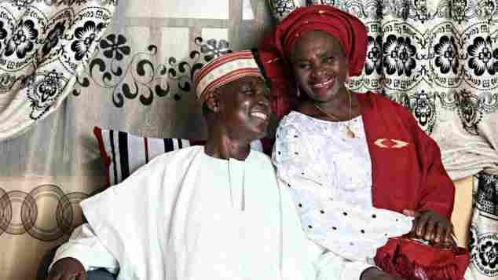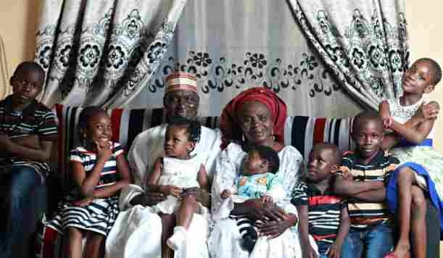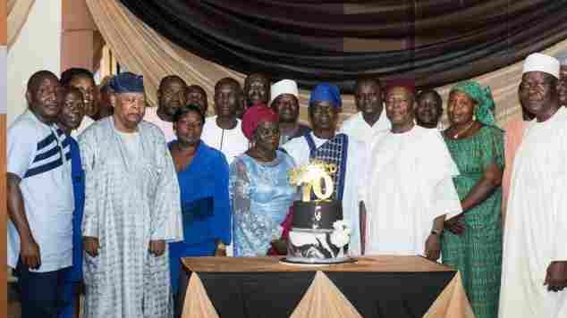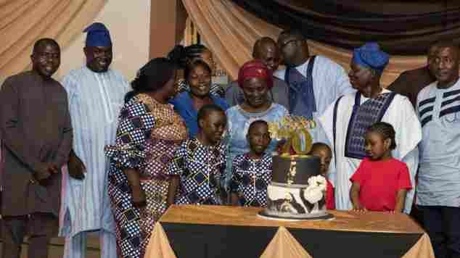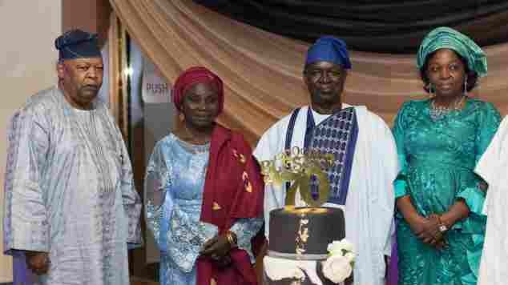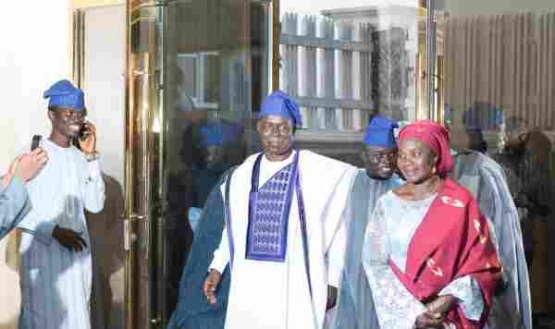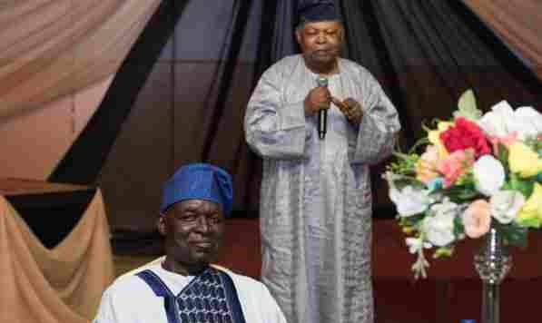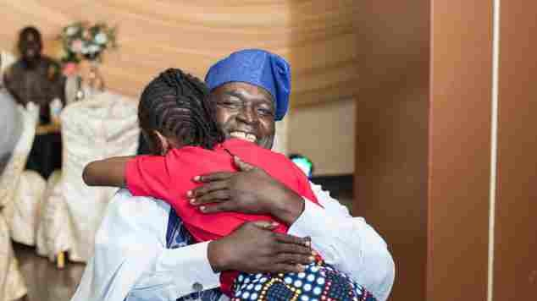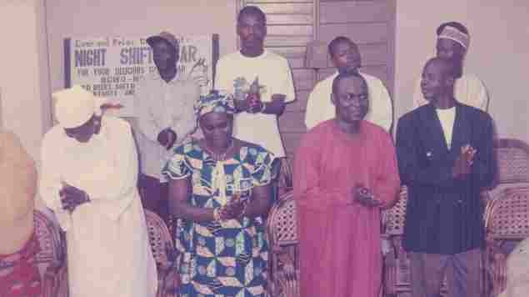

#### -01-

**Baba in a Church Service**

**Glorious Exit Late Hon. Baba Eli Gamaliel Tahbi**

**Baba reading Bible for his late father &**

**his Father Friend**

**Collecting Offering for LCCN Church Building in**

**Garki Abuja.**

**Honourable members of house of constituent assembly**

**Baba with his Friends**

**Baba, His wife and Children**

**As Human Resources Director of Sheraton Hotel With the GM Mr. Karl Frank**

**Giving award of Excellent to Staff at Sheraton Hotel**

**Baba in his office at Sheraton Hotel**

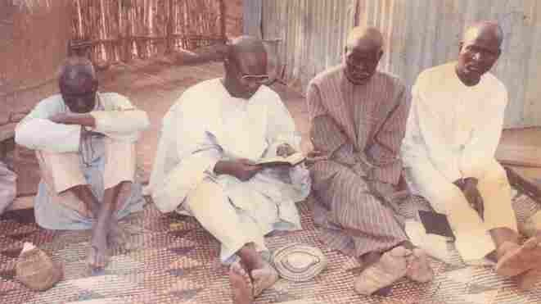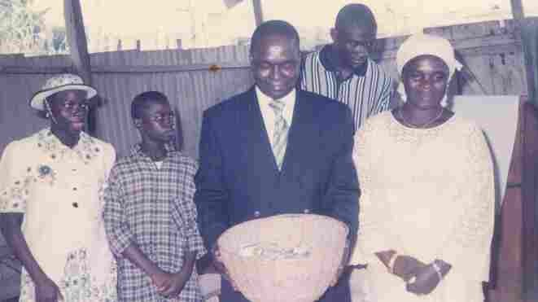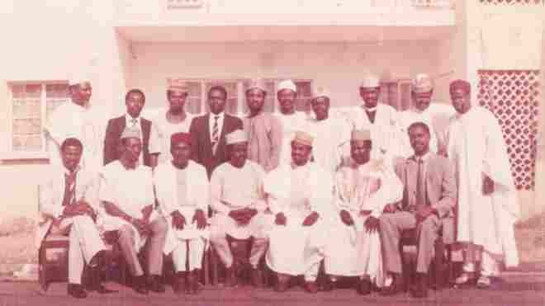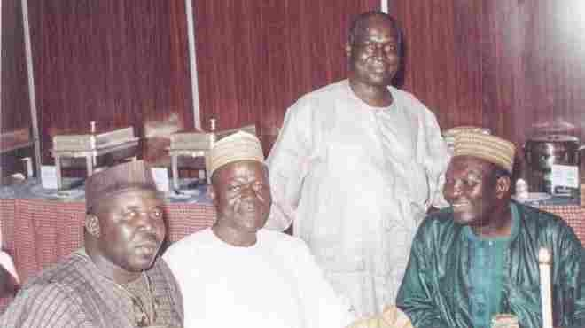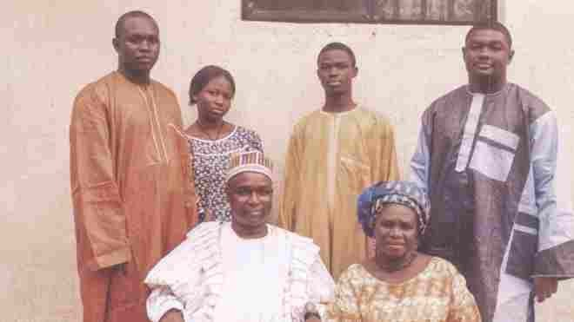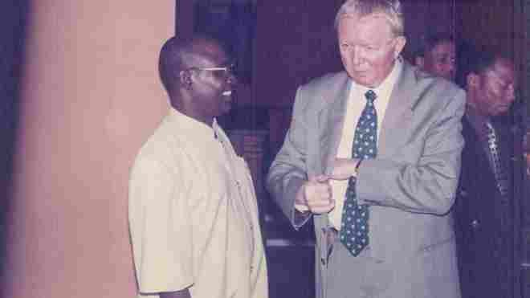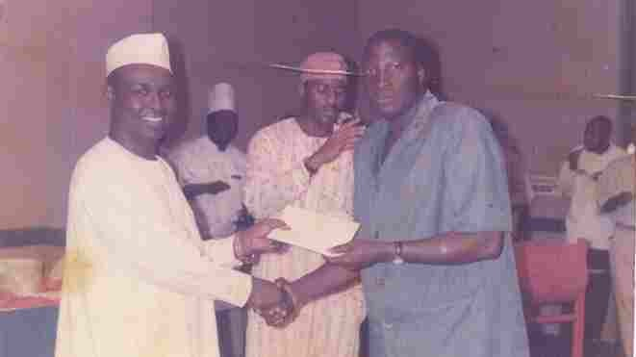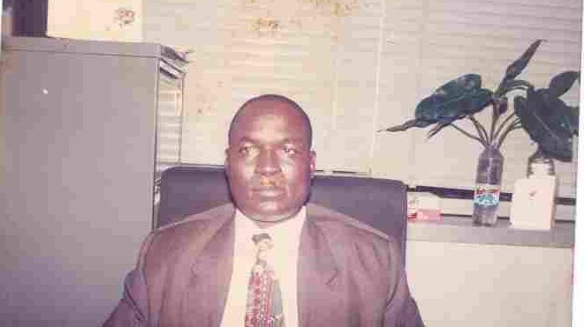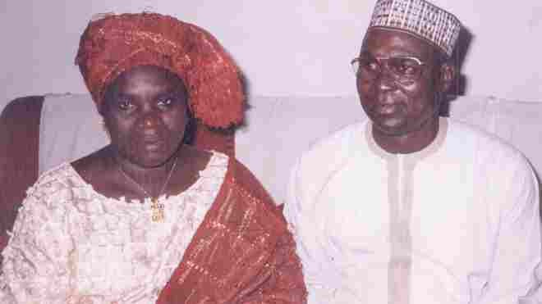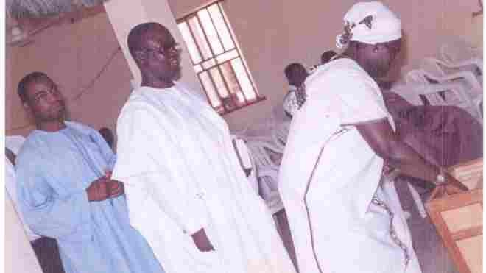

**Baba and his Wife**

#### -01-

**LCCN Church Building**

**Glorious Exit Late Hon. Baba Eli Gamaliel Tahbi**

# ribute

T

***BY FRIENDS & ASSOCIATES***

My dear Comrade, your departure is hard to believe but the Lord knows all. You leaved a loving and worthy for which we are proud. We pray to meet you to part no more.

**Senetor Dr. J. S. Zwingina**

A dear brother, Friend, and Political Associate of all times has gone home to rest in the bossom of the Lord. Rest in peace, Adieu my confidant.

**Boss Mustapha**

Adieu dear friend, you lived a fulfilled life as a middle belter of repute and your passing is a great loss to all of us. The indelible mark you have printed in the hearts of many in the Middle Belt Region, will remain with us and our memories of your commitment and good works will ever be remembered. Rest in the bossom of the Lord dear compatriot.

**Dr. Pogu Bitrus**

**(President Middle Belt Forum)**

A great gem has been lost. May his soul Rest in Peace.

**Sylvester N. Baruwa**

OMG. My colleague and friend have gone too soon but God knows why. It is an appointed time. The children and your wife with friends had fought the battle but the decision is final. We will miss you, especially when last I came and we talked at length and encouraged each other and you ate your food and your wife was very happy. Rest in Perfect Peace.

**Comr. Emmanuel Ishaku Balami**

RIP Daddy. Thanks for a life well lived and the children you have raised. You will forever be remembered.

**Pastor Isaac Ahangba Agwaza**

Baba, while you were with us, we enjoyed your contributions to discuss, you mentored and also gave us the younger generation, employment opportunities. We also noticed your footprint on the political landscape. Therefore, your departure has created a gap but you also left us a son, Barr. Jegu-Bara to build on your legacies. Thank you for all your efforts and endeavors. Just Journey well to the bossom of the Lord Jesus Christ and rest in peace.

**Alex Joseph Gwaske Chikila**

My dear brother, Mr. Eli Gamaliel, I miss you so very much. May your perfect soul rest with the Lord. We will certainly meet before him to part no more.

###### Hon. Wulbina Jackson

We have lost an icon, a father of many. LCDAAbuja will forever remember your legacies and you will

be greatly missed.



**LCDA Abuja**

**-01-**

**Glorious Exit Late Hon. Baba Eli Gamaliel Tahbi**

It is with profound sadness that we in Lunguda Development Association (LDA) received the news of the death of Comrade Eli Gamaliel.We remember with nostalgia how, as a Nurse, he gave hope, succor, encouragement, support and, invaluable nursing care to all and sundry.

We also remember in those hey days of Marxism how Comrade Eli Gamaliel, alongside Comrade (now Senator) Jonathan S. Zwingina and others, would courageously take on any government or authority on behalf of anyone whose rights were being denied or trampled upon. Their struggles against a well-entrenched feudalistic system not only raised our collective consciousness to the sanctity of citizens' rights and privileges but also added value to our shared journey through this life. Without Comrade Eli Gamaliel and his Marxist co-travelers' effort by now these feudal forces would have driven us aground. As we mourn Comrade Eli Gamaliel's loss, let us celebrate his life, his legacy, and the enduring impact he has had on each of us. Let his family, friends, and loved ones find solace in these cherished memories and the knowledge that Comrade Eli touched many lives in so many in profound ways.

Adieu Comrade!

###### My Dearest Husband,

**Chief Ibrahim A. Welye**

President, Lunguda Development Association

**FAMILY TRIBUTE**

my heart overflows with memories of our life together. You were not only my husband but my confidant, my rock, and my greatest supporter. Your love filled our home with warmth, laughter, and unwavering strength. You are irreplicable forever Rest peacefully, my beloved. Until we meet again.With all my love.



#### Mrs. Adah Eli Gamaliel

(Wife)

#### Baba you taught us integrity.

**Suri E. J. Gamaliel**

(Son)

“There was a man sent from God, whose name was ….” you Dad. My Father, Teacher, Mentor, Voice of wise counsel and friend; Now that you have joined the cloud of the spirits realms, your memory remains blessed and irreplaceable.

**Chief. Eli Jegu-bara Gamaliel, Esquire**

(Son)

My dearest dad, though now gone from my sight, your loving spirit remains imprinted on my heart. You taught me how to live with kindness, courage and joy. Today my weekends are going to be empty without you, but I know weather in bloom or blight God speaks to us and I am happy knowing you rest peacefully now. I will strive to honor you through how I live my own life, keeping your memories evergreen. We shall meet on the other side of eternity.

**Mr. Eli Duke Gamaliel (Son)**

Grandpa, you were the best person on earth. A very charismatic leader to us all. You were a humble and considerable man. Rest in peace.

###### Jasmine E. J. Gamaliel

**(Grand-daughter)**

#### -01-

**Glorious Exit Late Hon. Baba Eli Gamaliel Tahbi**



I miss grandpa. You were the best thing that ever happened to me so I want to say, Rest in Peace. I will meet you in the afterlife.

**Jemimah E. J. Gamaliel**

**(Grand-daughter)**

You are the best in my life. You loved me so much with and which you make heaven last.

**Jirah E. J. Gamaliel**

My father and model. If it was a dream, I wished never to sleep again. Accepting this reality is a difficult thing to do. Though, you taught me to always be strong, this time my strength has failed. Nevertheless,

I take solace in the fact that your resting in the bossom of the Lord. Rest on Daddy.

**Miss Bilha Vilson Gamaliel**

**(Daughter)**

When the morning comes, when the saints are all gathered home, we will tell the story of how we overcame and all our questions will be satisfactorily certified. Then sleep cool and rest assured that hope, faith, and love will preserve us. See you soon my humble brother.

###### Uncle Gamaliel Buram Buriba

**(Brother)**

I write with a heavy heart, but with total submission to the will of God Almighty, it pleases God to take you home, who can question God? He knows better. Yaya as I always called you, I know you are resting at the feet of our Lord Jesus Christ. Yaya we missed a father, a brother, and a friend, you will always be remembered in our hearts. Yaya rest in peace till we all meet at the feet of our Lord Jesus Christ and part no more. **Pst. Mrs. Comfort (Wunga) Yilkis**

**(Sister)**

I came in contact with Mr. Eli Gamali in 1996. We started as employer and employee, but as the relationship continued, we migrated to a father-and-son relationship. One thing that made the relationship stronger and stronger through to his death was Samson must not lie to his father no matter the offense committed. He taught me real discipline, truthfulness, and how to plan for a great future. I met him as a bachelor, but today, I have a great family. God used him to touch almost every area of my life. I can say clearly that in 95% of his programmes, he discussed them with me before execution. He was a father indeed, he gave me great encouragement while in a sick bed, he told me, Samson, the pain is not affecting my mind. Baba, his love for Samson is unparalleled and he love me on to death. I can conclude by saying “Baba sleep well until we meet in the bossom of the Almighty God.

**Mr Samson Otene**

Baba, I can't believe you are gone, that Tuesday morning I hurriedly came so you could take your medication and food, just for the Doctor to say you are gone. But I know you are resting with the Lord because to die in Christ is great gain. I will forever miss your advices, encouragements and your funny talks...Till we meet at the bossom of the Lord. Rest on.

**Kalieru Njidda**

You have taught me the value of a family, and I have watched you make many sacrifices for the family and share your life, time, and resources with your associate. You have demonstrated the act of forgiveness at every turn in your private and public life. Rest from your labour at the bosome of the LORD

**Dr. Sabo Robert**

#### -01-

**Glorious Exit Late Hon. Baba Eli Gamaliel Tahbi**

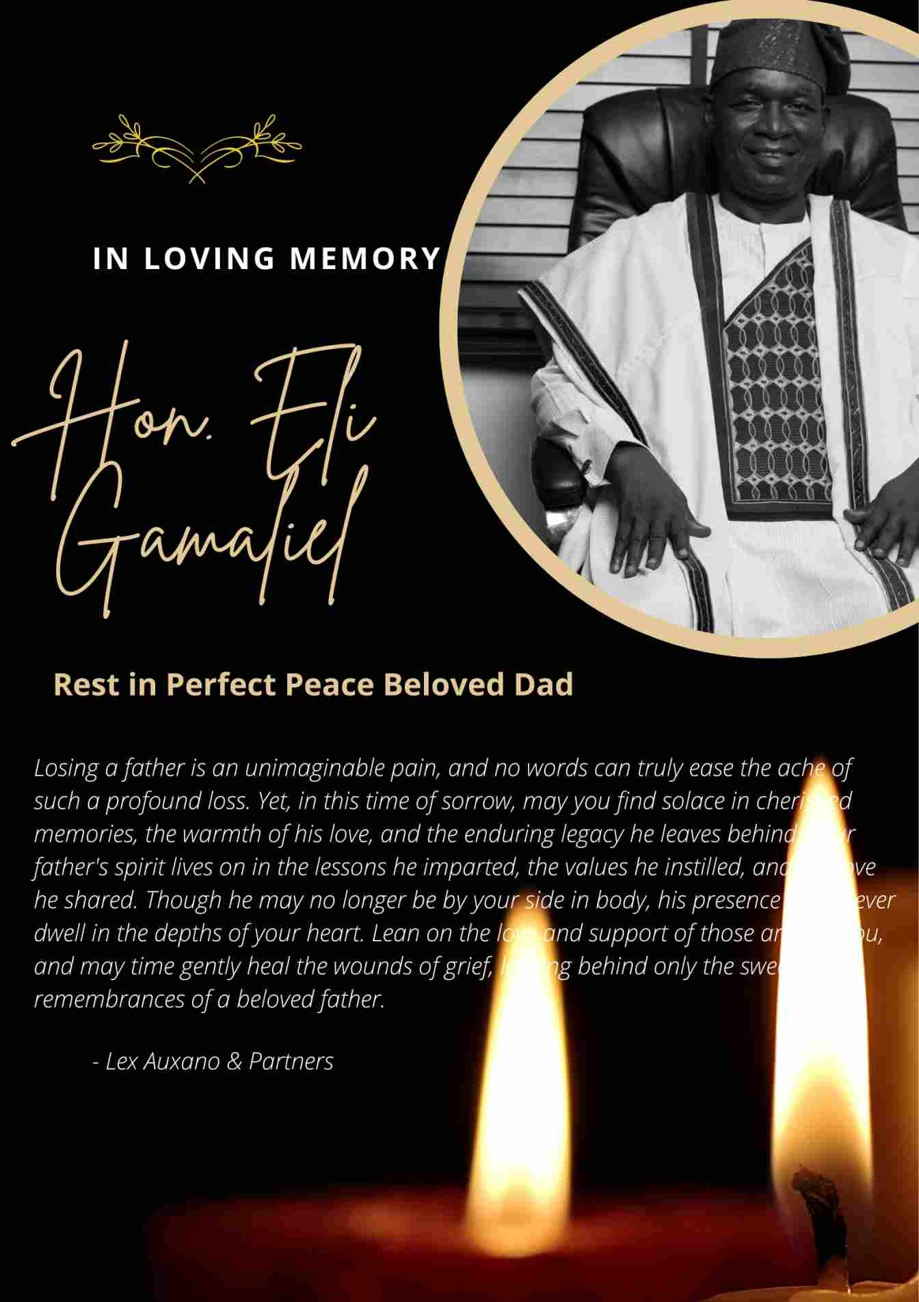

#### -01-



**Chief(Barr) Eli Jegu-bara Gamaliel (For the Gamaliel Family)**